Amanda Koen
EDU 590
akoengrad@gmail.com

Student Teaching Evaluation of Performance (STEP)

Table of Contents

Standard 1- Contextual Factors - Knowing Your School and Community
Standard 2 - Writing Standards-Based Objectives and the Learning Goal
Standard 3 - Assessment and Data Literacy
Standard 4 - Unit and Lesson Planning
Standard 5 - Implementation of Instructional Unit
Standard 6 - Analysis of Student Learning
Standard 7 - Reflecting on Instruction to Improve Student Progress

STEP Standard 1 - Contextual Factors: Knowing Your School and Community

Part I: Community, District, School, and Classroom Factors

A. Geographic Location
Springfield, OR

B. District Demographics
Total Students: 10,966
Classroom Teachers: 26
Student/Teacher Ratio: 20
ELL: 613
Students w/ IEP’s: 1,887

C. School Demographics
Total Students: 523
Classroom Teachers: 495
Student/Teacher Ratio: 22
Title 1 School

STEP Standard 1 - Contextual Factors: Knowing Your School and Community

Part II: Demographic, Environment, and Academic Factors

- Student Demographic Factors
Students:
4 Indian / 9 Asian / 5 Black / 154 Hispanic / 327 White / 24 Mixed
Male: 254
Female: 269
Free Lunch Eligible: 294
Reduced Price Lunch Eligible: 55

- Environmental Factors
Built in 1997, the school is in good condition. There are 3 main hallways that all meet in the center. Very wide hallways and large classrooms. The school has a very large field and playground, along with a blacktop play area for rainy weather days. The school is frequently investing in technology and furniture. Currently the school has 5 computer carts on wheels that are shared between teachers. Classrooms are supplied with projectors and document cameras.

- Student Academic Factors
Student Subgroup | ELL | IEP | Section 504 | Gifted | Other Services (Explain) | Behavior or Cognitive Needs Receiving No Services
Boys | 31 | 21 | 7 | 9 | # | #
Girls | 31 | 12 | 9 | 21 | # | #
Instructional Accommodations and Modifications  (Describe any instructional accommodations and modifications regularly used to meet the needs of students in each subgroup.) | Pull out instruction | Teachers and parents choose appropriate accommodations from a list | Resources provided to students | Placed in classroom with an endorsed teacher | Text | Text

In the space below, discuss the possible effect these characteristics could have on the planning, delivery, and assessment of your unit. Refrain from using student names.
Click here to

STEP Standard 2 - Writing Standards-Based Objectives and the Learning Goal

Unit Topic: The Environment

Unit Title: Main Idea and Details

National or State Academic Content Standards
RI.4.1 - Refer to details and examples in a text when explaining what the text says explicitly and when drawing inferences from the text.
RI.4.2 - Determine the main idea of a text and explain how it is supported by key details; summarize the text.
RI.4.3 - Explain events, procedures, ideas, or concepts in a historical, scientific, or technical text, including what happened and why, based on specific information in the text.
RI.4.4 - Determine the meaning of general academic and domain-specific words or phrases in a text relevant to a grade 4 topic or subject area.
W.4.2 - Write informative/explanatory texts to examine a topic and convey ideas and information clearly.
W.4.7 - Conduct short research projects that build knowledge through investigation of different aspects of a topic.
W.4.8 - Recall relevant information from experiences or gather relevant information from print and digital sources; take notes and categorize information, and provide a list of sources.
W.4.9 - Draw evidence from literary or informational texts to support analysis, reflection, and research.

Learning Goal
Students will be able to:
-Determine the main idea of a text and explain how it is supported by key details
-Explain events or ideas based on information in a text, using key terms
-Explain why it is important to be informed about what is happening in our world

Measurable Objectives
- Given 10 vocabulary words, students will identify the meaning with no more than 1 error.
- Given two passages, students will determine the main idea and 3 supporting details of each with no more than 2 errors
- Students will turn in a persuasive text that has at least 1 text reference/quote, a topic starter, a conclusion sentence, at least 3 supporting details, and effective transitions.

STEP Standard 3 - Assessment and Data Literacy
Pre-Assessment - Copy and paste the pre-assessment you plan to use to assess the students’ knowledge of the topic prior to implementing the unit lessons. Include the scoring criteria used to determine whether the student Exceeds, Meets, Approaches, or Falls Far Below the learning goal and measurable objectives.
Copy and past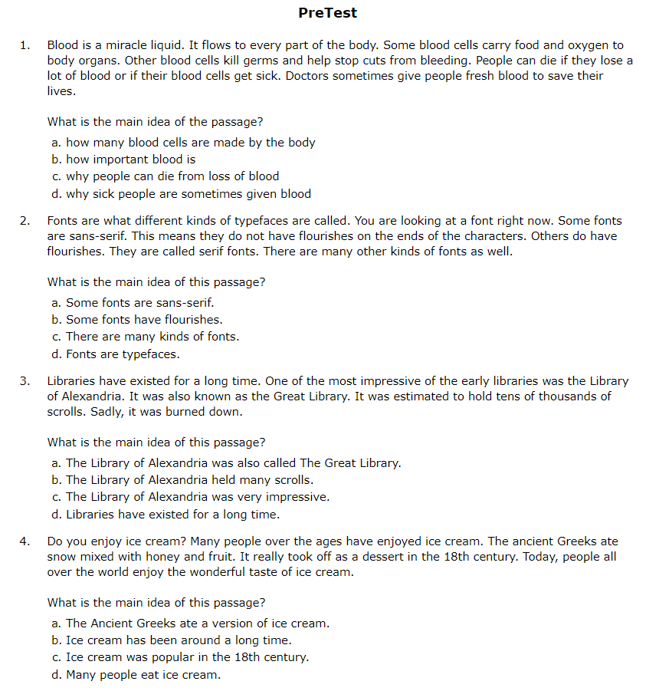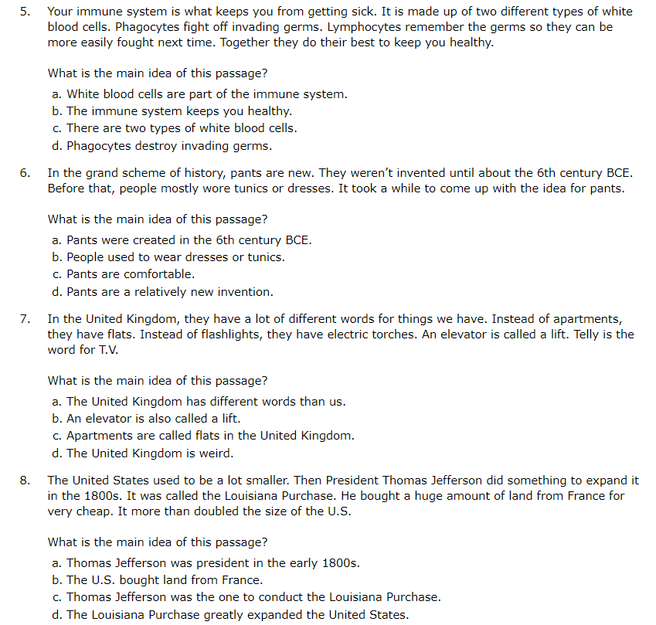
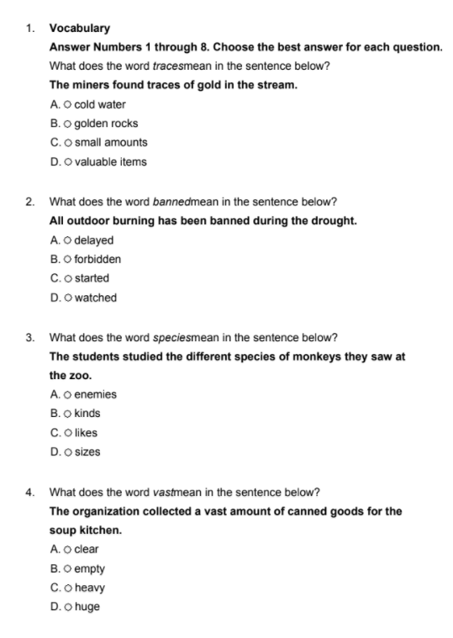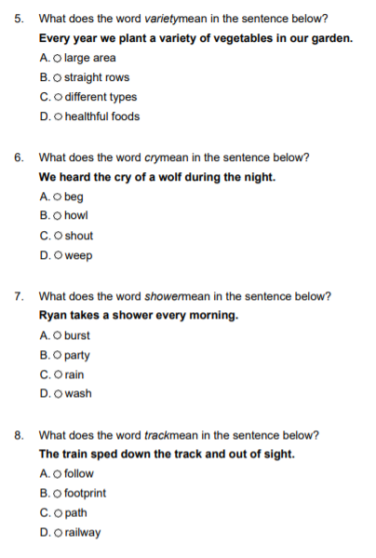
Each questions is worth 1 points. A score of 12 or higher on each test shows that the student has met standards.

Pre-Assessment Data: Whole Class - Once you have assessed your students’ knowledge on the topic, collect and analyze the pre-assessment data to determine if you will need to modify the standards, learning goal, or measurable objectives that will be addressed during instruction.

 | Number of Students
Exceeds | 0 / 0
Meets | 3 / 1
Approaches | 27 / 29
Falls Far Below | 2 / 2
Pre-Assessment Analysis: Whole Class

Based on the data above, what changes, if any, will you make to your selection of national or state academic content standards, the learning goal, or measurable objectives?
None. I am prepared to teach students the lesson - from the ground up.
Based on the data above, describe in 1-3 paragraphs the effect this data could have on the planning, delivery, and assessment of your unit.
Many students fall below their grade level in reading. I will need to allow extra cushion in my time frames in order to allow maximum flexibility. The students are mostly all at risk, so I will need to choose activities that are highly engaging. I will also need to make sure that I have multiple styles of teaching in order to accomodate for all learning styles. There are a lot of behavioral issues within the classroom, so it is crucial that I am full prepared and that I have an excellent management plan in place.

Post-Assessment – Copy and paste the post-assessment you plan to use to assess the students’ knowledge of the topic after implementing the unit lessons. The post-assessment can be the same as the pre-assessment, a modified version, or something comparable that measures the same concepts. Include the scoring criteria used to determine whether the student Exceeds, Meets, Approaches, or Falls Far Below the learning goal and measurable objectives.
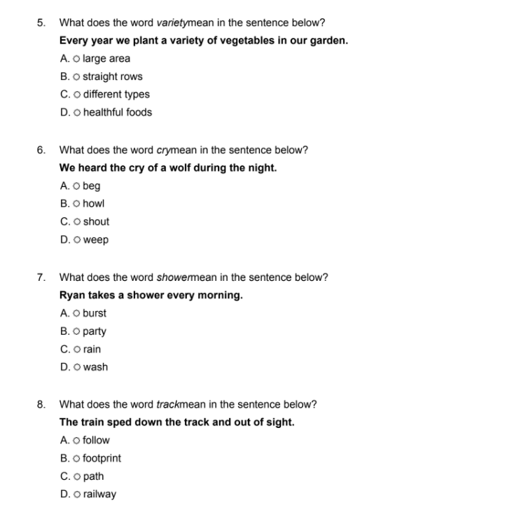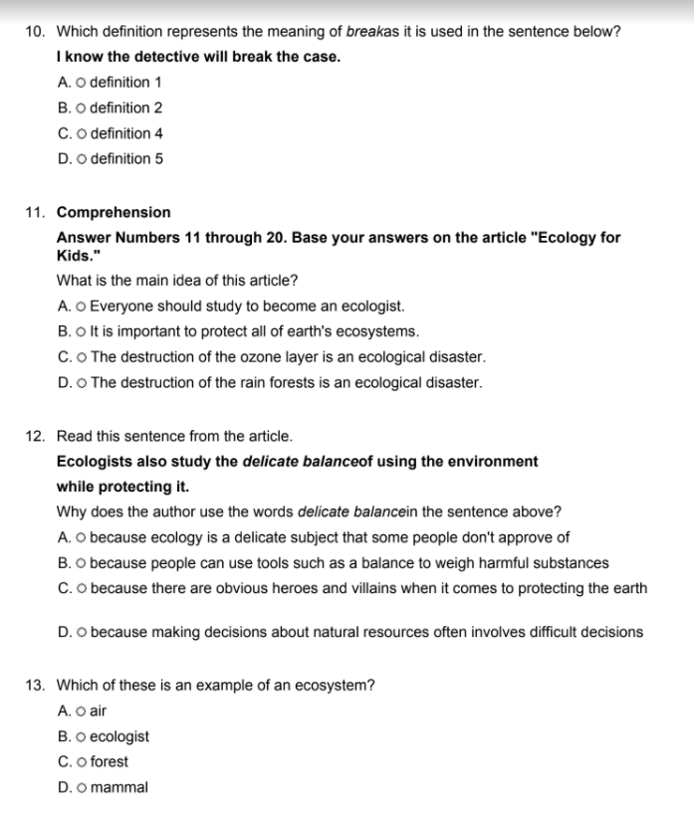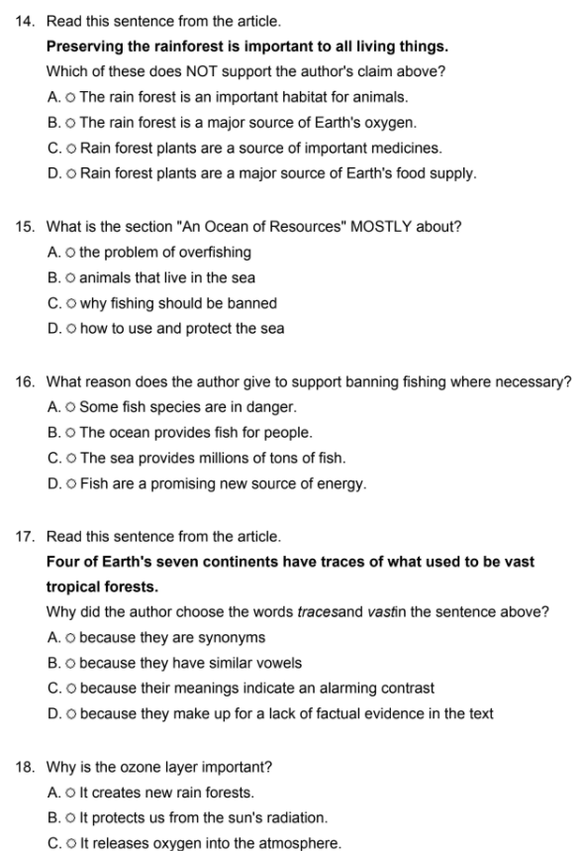

Grading will be done via our computer learning program. Students will need to get 14/80% questions right in order to have mastered the concepts.

STEP Standard 4 - Unit and Lesson Planning
Note: When implementing the unit of study, you will be choosing one of these activities to video record, review, and reflect on your teaching later in the STEP process,

 | Day 1 | Day 2 | Day 3 | Day 4 | Day 5
Title of Lesson or Activity | Ecology For Kids | Vo-Do-Jo (Vocabulary) | Main Idea & Supporting Details | Test Prep | Click here to enter text.
Standards and Objectives  What do students need to know and be able to do for each day of the unit? | CCSS.ELA-LITERACY.RL.4.10  By the end of the year, read and comprehend literature, including stories, dramas, and poetry, in the grades 4-5 text complexity band proficiently, with scaffolding as needed at the high end of the range. | CCSS.ELA-LITERACY.RL.4.4  Determine the meaning of words and phrases as they are used in a text, including those that allude to significant characters found in mythology (e.g., Herculean). | CCSS.ELA-LITERACY.RL.4.2  Determine a theme of a story, drama, or poem from details in the text; summarize the text. | CCSS.ELA-LITERACY.RL.4.2  Determine a theme of a story, drama, or poem from details in the text; summarize the text. | Click here to enter text.
Academic Language and Vocabulary  What academic language will you emphasize and teach each day during this unit? | While reading the text, we will introduce the units vocabulary words:  Variety  Vast  Species  Direct  Organism  Banned | Variety  Vast  Species  Direct  Organism  Banned | Variety  Vast  Species  Direct  Organism  Banned | Variety  Vast  Species  Direct  Organism  Banned | Click here to enter text.
Summary of Instruction and Activities for the Lesson  How will the instruction and activities flow? Consider how the students will efficiently transition from one to the next. | Today, we will read our anchor text: Ecology For Kids. The essential questions asks “Why is it important to know what is happening in our world?”. Students will be able to answer the question by the end of the lesson. I will read the text out loud to students, and then I will have them read the story a second time silently to themselves. We will discuss the essential question at the end. | I will review vocabulary words with students and hold a fun competition. | I will review what main idea is and methods for determining the main idea. Afterwards, I have stations set up for students to participate in. | Today students will work on their computer program - MobyMax reading. | Click here to enter text.
Differentiation  What are the adaptations or modifications to the instruction/activities as determined by the student factors or individual learning needs? | None needed | None needed | None needed | None needed | Click here to enter text.
Required Materials, Handouts, Text, Slides, and Technology | Journeys books | Vocabulary cards and prize bucket | Stations | Computers & Headphones | Click here to enter text.
Instructional and Engagement Strategies  What strategies are you going to use with your students to keep them engaged throughout the unit of study? | Walking around the classroom, reading with personality, asking questions, and requiring students to trace along as I read. When I stop at a work students say the next word. | I have students using their bodies to participate in a fun competition. | I have students engaged in a variety of stations where they have the opportunity to pick an activity or game. They get to choose independent work or group work. | Students have fun playing Mobymax because students can earn game time. | Click here to enter text.
Formative Assessments  How are you going to measure the learning of your students throughout the lesson? | I am asking questions as I read. | As students play the game, they should get better at giving definitions. | I will walk around, ask questions, and pay attention to what students are saying. | The program will provide me with student progress and scores. | Click here to enter text.
Summative, Post- Assessment | The final test will be taken on a computer. Students will be allowed to use their books.  The test is a slightly modified version of the the pre-assessment. The final test requires  that they choose main ideas of short passages and the story we read, Ecology for Kids.  Students will also need to define vocab words based on their use in a sentence.

STEP Standard 5 - Implementation of Instructional Unit
Implement the unit you have designed including the pre-assessment, all lesson activities, correlating formative assessments, and summative post-assessment. Choose one of the activities to video record, review, and reflect on your teaching. Have your cooperating teacher/mentor review the recording and provide feedback, if possible.

Video Recording Link: If you are turning your video in through OneDrive, just note it here.

Summary of Unit Implementation:
Click here to enter text.

Summary of Student Learning:
Click here to enter text.

Reflection of Video Recording:
Click here to enter text.

STEP Standard 6 - Analysis of Student Learning

Post-Test Data: Whole Class - Once you have assessed your students’ learning on the topic, collect and analyze the post-test data to determine the effectiveness of your instruction and assessment.

 | Number of Students  Pre-Test | Number of Students  Post-Test
Exceeds | 0 | 2
Meets | 9 | 21
Approaches | 16 | 3
Falls Far Below | 4 | 3

Post-Test Analysis: Whole Class

I was really surprised at how well students did considering how many interruptions we have had to deal with. I noticed a huge improvement by using a Pre-Test. I had 21 students meet the expectations for the post-test with a Pre-Test, whereas previously only 16 or so students meet expectations on a previous lesson. I feel that a Pre-Test helped me really focus our lessons, but also allowed students a chance to see what to expect on their tests. I feel Pre-Tests can help alleviate some anxiety. I will definitely use pre-tests for the majority of my subjects.

The first time I started working with this class on vocabulary, I thought I was doing such a great job. However, tests proved me otherwise. I tried several methods including games, performance skits, writing, and a review of the test the day before. I had to go back to the drawing board to figure out another method. I found word webs and gave it a try. Also, instead of reviewing all words for two days, I spread the words out so that we talked about 4 words each day. I allowed students to come up with synonyms, antonyms, sentences, and connections. So far, this method is working out much better. Students averaged about 50-60% previously, and jumped to 80%. I’m really learning to work with my students to figure out how they learn best - and Im getting to learn and try new methods in the process.

Post-Assessment Analysis: Subgroup Selection

I am going to review my hispanic students subgroup. I have approx 6 students who are ESL students. These students do not receive any intervention.
Post-Assessment Data: Subgroup (Gender, ELL population, Gifted, students on IEPs or 504s, etc.)

 | Number of Students  Pre-Test | Number of Students  Post-Test
Exceeds | 0 | 0
Meets | 1 | 2
Approaches | 1 | 2
Falls Far Below | 4 | 1
Post-Assessment Analysis: Subgroup
I noticed that these students struggle the most with basic vocabulary. I have noticed this in my other subject areas as well.

I was disappointed in myself for forgetting some of the tools I have learned through GCU, particularly for ESL students. These students spoke English so well in class I didn’t feel there was a need for adjustments, but I can see otherwise with I review their performance scores. I am going to remember to set time aside for these students to create foldables and graphic organizers.

Post-Assessment Data: Remainder of Class

 | Number of Students  Pre-Test | Number of Students  Post-Test
Exceeds | 0 | 2
Meets | 8 | 19
Approaches | 15 | 1
Falls Far Below | 0 | 2

Post-Assessment Analysis: Subgroup and Remainder of Class

Both groups had about 50% of the students move up one benchmark. However, I did not have any ESL students meet the “exceeds” benchmark. I feel that vocabulary and more hands on experience with visual is needed for my ESL students. While it looked like they understood what we were learning as a class, there were still some comprehension issues. It is amazing to me the learning differences, no matter how small, and how they add up to impact student learning.

Students will begin learning about story elements. Understanding main idea will help students understand plot. I will be sure to use a visual aid and place special emphasis on vocabulary for students who are ESL. I have a worksheet that helps visually clarify the elements of a story.

STEP Standard 7 – Reflecting on Instruction to Improve Student Progress
Improved Practice Based on the Unit of Study
Based on the experience of developing and delivering your instructional unit, list three short-term goals to improve specific areas of your teaching practice based on the unit of instruction and describe your plan to reach each short-term goal.

Short-Term Goal | Plan to Reach the Goal (i.e., professional development, research on the Internet, observation of a veteran teacher, etc.)
Incorporate more differentiation for ESL students | I will research ESL learning tools and utilize them in the classroom. Examples include word webs and graphic organizers.
Provide better instructions in multiple formats. | I will make sure instructions are available both visually and auditorily. I will have premade example of work for students.
Provide better scaffolding. | I will observe veteran teachers and how they scaffold learning. I will use methods like Gradual Release to teach students.

